RFQ 19-019 E-Waste Services Questions and Answers

A possible bidder has asked questions.

- Do you have a breakdown of commodities and their amounts from previous years? See attached 2018 bid attached file.
  - Frequency of pickups? Once every other month
- Who currently holds the contract and are you able to share the current pricing you are under?
- Are you able to hold items until you have a full trailer load? Yes
- Are you able to hold certain commodities (ex. CRTs) until you have a full load? – we have partners we can use to get better pricing for certain items (depending on the area) Yes, we can
Depending on pricing.

We hold a residential e-waste collection one Saturday every other month. We generally collect a 53’ trailer load (Including Crt’s etc.. We will work with you in any way
That is mutually beneficial. We Have Inmate labor to collect the E-waste and Package it and load the truck at your drivers direction.
My secretary is out with the Flu today, so I can’t put my hands on actual paper work for E-waste that has been collected. The CRT T.V.’s are still coming in but the Flat screens
Have picked up in recent years.
Every event is different as far as what we get in. We always get T.V’s and Monitors of all types, computers (Desk Tops and Lap Tops) Printers and other computer related items. Radios, electronic games, printer cartridges,
And sometimes electronics that I have never seen or heard of before.

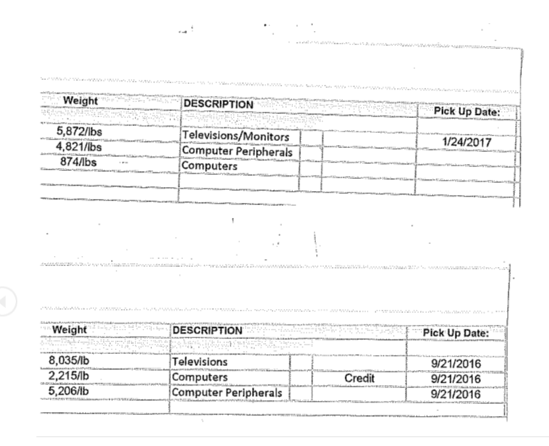

2018 E-Waste Quotes
+= Pay '-=Cost | Ossie@Allsource-eviromental | Jeffrey@FirstAmericametal | Phillip@premiersurplus
Desk Top | +.25/lb | +.25/lb | +.18/lb
LapTop | +.25/lb | +.60/lb | +.59/lb
CRT T.V. | -0.25/lb | -0.30/lb | -0.24/lb
CRT Monitor | -0.25/lb | -0.30/lb | -0.24/lb
Flat Screen T.V. | -0.25/lb | -0.20/lb | -0.24/lb
Flat Screen Monitor | -0.25/lb | -0.20/lb | -0.24/lb
Computers/Other | +.25/lb | +.20/lb | +.09/lb
Peripherials | No pay no Charge | -.05/lb | +.03/lb
House Hold Electronics | -.25/lb | -.05/lb | +.02/lb
LCD Monitors | -.25/lb | No Charge | -.25/lb
Tape | yes/Will Reimburse | No | yes/no charge
Shrink Wrap | yes/Will Reimburse | No | yes/no charge
Gaylords | yes/no charge | No | yes/no charge
Pallets | yes/no charge | No | yes/no charge
Transportation | yes/no charge | yes/no charge | yes/no charge
Trailer | yes/no charge | yes/no charge | yes/no charge
Event Collection | yes/no charge | Not Available | yes/$675.00 Flat Charge
 | 1747.75 | 2358.45 | 1217.52

